Create a new database named CDAC and connect to it



View list of available collections in CDAC database



Create a new collection by the name of LIBRARY

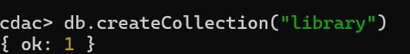

Insert the following document in the LIBRARY collection:- title:'MongoDB programming', author:'Sameer', likes:100

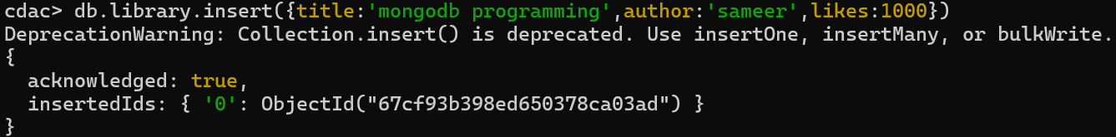

View the recently inserted document and note the _id field

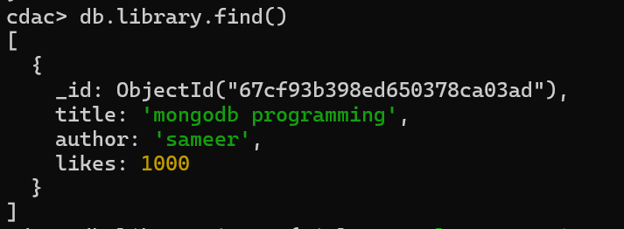

Insert another document in the LIBRARY collection as follows:- title:'MySQL programming', authors:['Jack','Jill'], likes:200

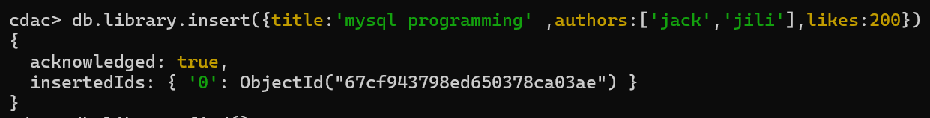

View the inserted documents

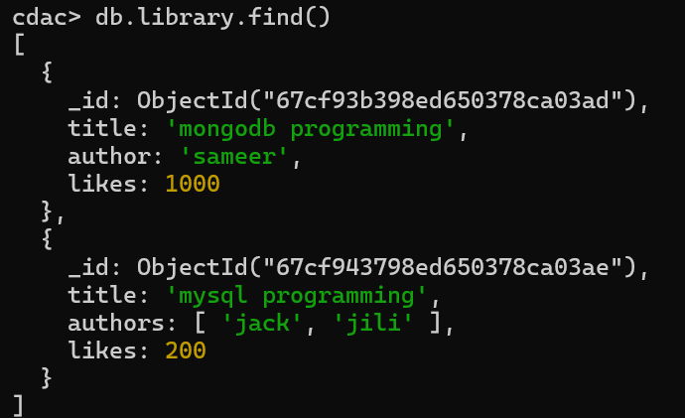

View only the first inserted document

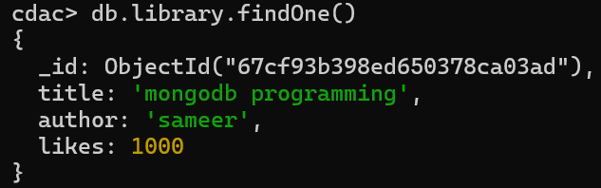

View the documents using the pretty() method

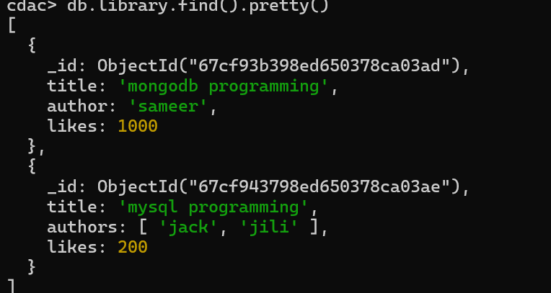

Update the document where author name = Sameer and change it to Sameer Dehadrai

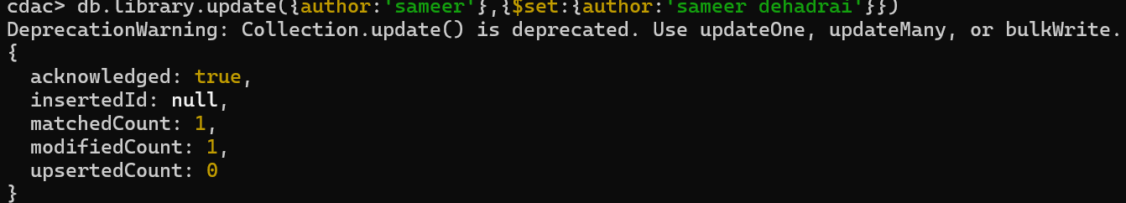

Delete all documents that have 100 likes



Drop the LIBRARY collection



Drop the CDAC database



Exit from MongoDB shell

